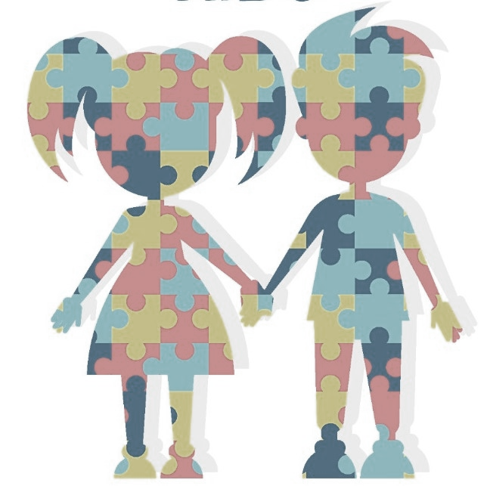

Autismo

Project Description Document

Submitted by:

Ubaid ur Rehman 123495

Iqra Rafiq 121028

Khursand Shakeel 126892

Date: January 10, 2018

Class: BSCS – 5

NUST – SEECS, Islamabad, Pakistan

Contents

Introduction 3

Educational Definition of Autism 3

Problem Statement 4

Solution 4

Solution's Novelty 4

Design 4

Implementation 5

More about Autism 5

Autism Literature Review 6

Genetics 6

Environment 6

Incidence 6

Diagnosis 6

General Health 6

Biomedical Treatments 7

Nutrition 7

Speech 7

Early Intervention 7

Prevention 7

Conclusions 8

# Introduction

According to the Centers for Disease Control and Prevention (CDC), the numbers of children identified with Autism Spectrum Disorder (ASD) continues to rise.

Autism has been referred to as a “spectrum disorder”, which suggests that the symptoms and characteristics associated with the disorder present themselves in variety of combinations, ranging along a continuum from mild to severe. It is typically characterized by impairments in socialization, verbal and non-verbal communications, and the capacity for imaginative thinking that results in exaggerated and stereotyped interests, behaviors, and activities. As such, two children, both of whom have a diagnosis of autism, may vary widely in terms of their functioning and their corresponding educational needs within each of these domains. Given this diversity in individuals with autism, professionals in the field began to use the term Autism Spectrum Disorder.

The term “spectrum” reflects the wide variation in challenges and strengths possessed by each person with autism.

Autism, or autism spectrum disorder, refers to a range of conditions characterized by challenges with social skills, repetitive behaviors, speech and nonverbal communication, as well as by unique strengths and differences. We now know that there is not one autism but many types, caused by different combinations of genetic and environmental influences.

## Educational Definition of Autism

Autism, as defined under IDEA, is a developmental disability significantly affecting verbal and non-verbal communication and social interaction, generally evident before age three that adversely affects a child’s educational performance. Other characteristics often associated with autism are engagement in repetitive activities and stereotyped movements, resistance to environmental change or change in daily routines, and unusual responses to sensory experiences. The term does not apply if a child’s educational performance is adversely affected primarily because the child has an emotional disturbance.

# Problem Statement

Autistic children face a number of difficulties in learning basic concepts and communication. There is very little known advancement in the field of ICT in this field.

# Solution

The solution is to develop an interactive mobile application specifically for autistic children and generally for all children who have basic knowledge of communication in English and have access to android enabled smart devices.

## Solution's Novelty

The application (Autismo) is supposed to play an important role in the mental growth of Autistic children. It would help them in some interactive therapies and would let them learn some basic early education concepts. Sharpen their minds with some fun games and interesting activities.

# Design

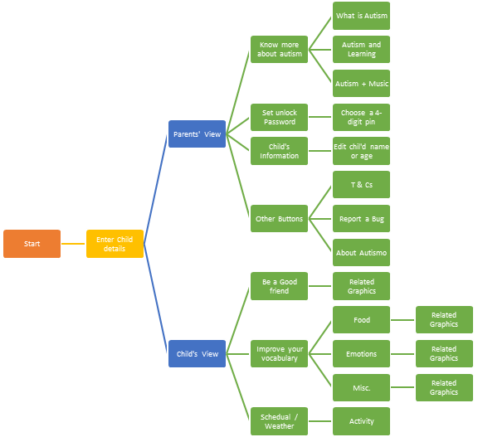

# Implementation

The main design constraint is that the application must be usable by people with Autism spectrum conditions, therefore the proper considerations must be made for the users. Another major constraint is that application must be in native language so that it will be easy to understand for local users. There are certain safety requirements that we must follow

The Autismo application will be developed in java using the android SDK on android studio. Therefore, Autismo application will comply with the programming practices of JAVA.

The delivered software will be open-source and publically available for developers to further work on it. Software will be published on Google Play Store.

# More about Autism

Autism’s most-obvious signs tend to appear between 2 and 3 years of age. In some cases, it can be diagnosed as early as 18 months. Some developmental delays associated with autism can be identified and addressed even earlier. Autism Speaks urges parents with concerns to seek evaluation without delay, as early intervention can improve outcomes.

#### Some facts about autism

* The Centers for Disease Control and Prevention (CDC) estimates autism’s prevalence as 1 in 68 children in the United States. This includes 1 in 42 boys and 1 in 189 girls.
* An estimated 50,000 teens with autism become adults – and lose school-based autism services – each year.
* Around one third of people with autism remain nonverbal.
* Around one third of people with autism have an intellectual disability.
* Certain medical and mental health issues frequently accompany autism. They include gastrointestinal (GI) disorders, seizures, sleep disturbances, attention deficit and hyperactivity disorder (ADHD), anxiety and phobias. (What is Aitism? || Autism Speaks, n.d.)

# Autism Literature Review

In the face of an exploding incidence of childhood developmental abnormalities, scientific knowledge is sorely lacking. These are our top picks for the most useful human research that improves our understanding about the cause(s) and treatment(s) of these conditions.

### Genetics

The Journal of Developmental Behavioral Pediatrics published research that demonstrated, “… ASD rates were 11.30% and 0.92% for younger siblings of older affected and unaffected siblings, respectively… Risk remained higher in younger boys than girls regardless of the sex of affected older siblings.”

### Environment

New research has appeared, noting [Aerial spraying](https://www.sciencedaily.com/releases/2016/04/160430100405.htm) to combat mosquitoes linked to increased risk of autism in children.

### Incidence

A new study was published documenting the increased incidence of ASD in preterm births. “These results can be used to help show the importance of adequate prenatal care to help reduce the prevalence of preterm births, which can hopefully help to reduce the prevalence of ASD.”

### Diagnosis

Appearing in last year’s [literature](http://www.nature.com/articles/srep19164) was an article describing a new blood biomarker for autism. “In this discovery study, the ASD1 peptide was 66% accurate in predicting ASD.”

### General Health

Perhaps not surprisingly, a recent [study](https://www.autistica.org.uk/wp-content/uploads/2016/03/Personal-tragedies-public-crisis.pdf) documented significantly shorter life span for patients with ASD. However, the reduction was an alarming 18 years.

### Biomedical Treatments

The credibility of diagnosing medical issues and addressing abnormalities in systems throughout the body was boosted in an [article](https://www.ncbi.nlm.nih.gov/pmc/articles/PMC4910649/) by Drs. Frye and Rossignol (president of The Medical Academy of Pediatric Special Needs).

### Nutrition

Low vitamin D levels are ubiquitous in the practice of Special Needs Pediatric Medicine. Breastfeeding moms [should supplement](http://ajph.aphapublications.org/doi/abs/10.2105/AJPH.2015.303021). The problem may stem from [low levels in the Mom](https://www.sciencedaily.com/releases/2016/08/160830101350.htm).

### Speech

Using [high dose folic acid](http://www.nature.com/mp/journal/vaop/ncurrent/full/mp2016168a.html) may provide significant relief for our patients who suffer from speech apraxia. The main challenge is acquiring the supplement at an affordable price.

### Early Intervention

In spite of last year’s [US Task force on Autism](http://www.theautismdoctor.com/response-to-inaction-by-us-taskforce-on-autism/) declaration that early screening is not warranted, research in November’s [Lancet](http://www.thelancet.com/journals/lancet/article/PIIS0140-6736(16)31229-6/fulltext) concluded, “long-term symptom reduction after a randomized controlled trial of early intervention in autism spectrum disorder.”

### Prevention

A study in the Journal of the American Medical Association [concluded](http://jamanetwork.com/journals/jamapediatrics/article-abstract/2476187), “Use of antidepressants, specifically selective serotonin reuptake inhibitors, during the second and/or third trimester increases the risk of ASD in children, even after considering maternal depression.

Another [evidence](http://ije.oxfordjournals.org/content/early/2016/06/27/ije.dyw115.full.pdf+html) supporting:  [another pharmaceutical connection](http://www.theautismdoctor.com/an-autism-prevention/) to autism was presented. “Prenatal acetaminophen exposure was associated with a greater number of autism spectrum symptoms in males and showed adverse effects on attention-related outcomes for both genders…”

# Conclusions

There is the Bettleheim effect (he popularized the ‘refrigerator mom’ theory), the Wakefield effect (any new idea about autism becomes suspect), the vaccine effect (just talking about ASD leads to this controversy), and the continued debate about whether there even really IS an epidemic.

However, practically everyone, nowadays, knows some family that is touched by this developmental disorder. We must continue to hope that progress will accelerate in response to the reality of a condition that affects so many of our children